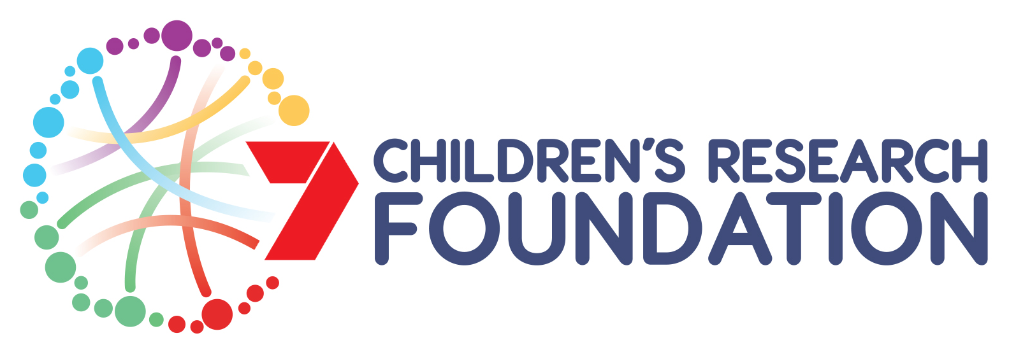


Healthy Development Adelaide and Channel 7 Children’s Research Foundation PhD Excellence Award 2023

Call to HDA members for applications

Value
The PhD Excellence Award are $5,000 per annum for up to 3 years only to augment an Australian Government Research Training Program (AGRTP) Stipend Scholarship or equivalent competitive scholarship.

Eligibility
Applications are invited for PhD Research Scholarships in the areas of Healthy Development: Disciplines include, but are not restricted to, allied health, biochemistry, biomedical engineering, biostatistics, demography, dentistry, digital health, disability, economics, education, endocrinology, epidemiology, ethics, genetics, indigenous health, law, nutrition, obstetrics and gynaecology, paediatrics, pharmacology, physiology, politics, psychiatry, psychology, public health and sociology. https://health.adelaide.edu.au/healthy-development-adelaide/our-research

Preference will be given to projects with a multidisciplinary focus and that enhance more than one discipline within the research topic.

Applications are invited from domestic and international students in their first year of candidature are eligible to apply i.e. commencement date between 1 April 2022 and 31 March 2023. Applicants should be eligible to enrol or be currently enrolled at either the University of Adelaide, University of South Australia or Flinders University. The stipend will be paid to your university, to be provided to you as a scholarship top up for the duration of your PhD for up to 3 years. In addition applicants must satisfy each of the following criteria.

- Applicants must hold a first class Honours degree or equivalent in a discipline relevant to the chosen field of study
- Applicants hold an Australian Government Research Training Program (AGRTP) Stipend Scholarship or equivalent competitive postgraduate scholarship
- Applicants must be a ‘paying’ HDA member. Membership is $20 (exc GST) for 1 year or $50 (exc GST) for 3 years https://health.adelaide.edu.au/healthy-development-adelaide/get-involved
- Applicants must have a HDA member as their primary/principal supervisor. Supervisors must be a ‘paying’ member. Membership is $20 (excluding GST) for 1 year or $50 (excluding GST) for 3 years https://health.adelaide.edu.au/healthy-development-adelaide/get-involved
- Research projects must be aligned with the Healthy Development research pillars spanning preconception to adolescence

Conditions of Funding

Successful HDA Scholars will be required to participate in the HDA Research Training Program during their candidature. The program consists of a 20 hour practicum placement, mentoring component, and attending and assisting as required at HDA events.

Annual renewal of top-up funding will also be subject to meeting your University postgraduate requirements, and subject to ongoing funding availability from the Channel 7 Children’s Research Foundation.

Acknowledgement of HDA in research publications.

Please submit the following documents by 5.00pm Friday 20 January 2023 to:
Healthy Development Adelaide, Anne Jurisevic at anne.jurisevic@adelaide.edu.au
- Completed HDA Application (doc format - in font Arial 12)
- Up-to-Date curriculum vitae
- Australian Government Research Training Program (AGRTP) or equivalent competitive scholarship Letter of Award
- Academic transcript

Healthy Development Adelaide and Channel 7 Children’s Research Foundation PhD Excellence Award 2023

HDA Application

Closing date: 5.00pm Friday 20 January 2023

Submission Date:
Applicant
Surname: |  |  | First Name:
PhD Student | PhD commencement (dd/mm/yyyy):
 | Full name of scholarship awarded:
University and Department/s
Telephone: |  |  | Email:
Primary/ principal supervisor: |  |  | Telephone & email:
Co-supervisors |  |  | Institution & contact email
PhD Project Title
Provide a title here

PhD Project & relevance to HDA
Provide a brief description ‘in lay terms’ of your research project, and indicate how it aligns with the research pillar/s of Healthy Development. Provide also a brief statement of how your research project and/or supervisory team meet the multidisciplinary criterion required for this scholarship. (total content: 250-350 words)

Name of Applicant |  | Signature of Applicant |  |  | Date
Name of Primary HDA Supervisor |  | Signature of Primary Supervisor |  |  | Date

